THESIS DISCUSSION:

**Topic1 :** CONVEYOR TRACKING:

**Step1:**

COORDINATE SYSTEMS:

* Machine coordinate systems (MCS)
* Tool coordinate systems(TCS)
* Tool plate coordinate systems(TPCS)
* Part coordinate systems(PCS)(object)
* Tool centre point(TCP)
* World coordinate systems(WCS)
* Axis coordinate systems(ACS)(motor coordinate system)

▪While object moving through the conveyor belt the PCS do not change.

**Step2:**

FUNCTION BLOCK:

1. Define the initial position of the object

2. Put an offset for the object (Conveyor belt origin)

3. Using an camera/laser we can detect the initial position of the object

4. Define the sync zone (have start zone: distance form the initial object position

to sync zone and end distance: distance between initial position of object and

end of sync zone)

1. Track options (it include the sync zone and sync out zone)

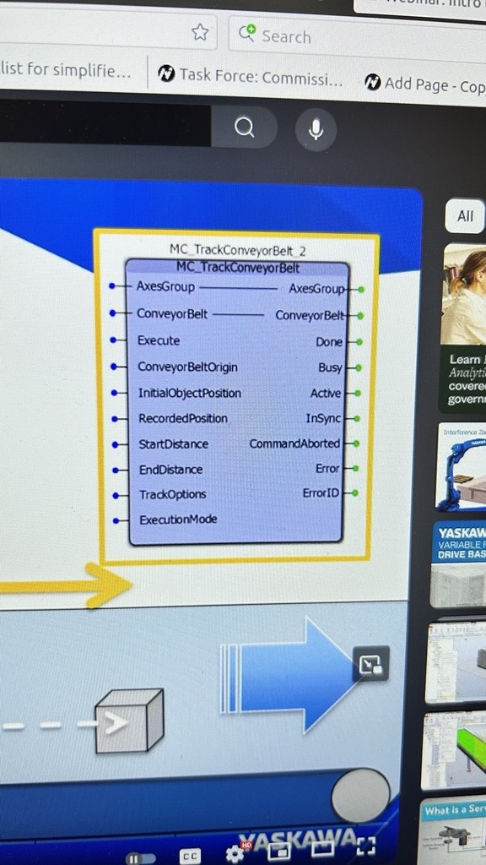

**Step3:**

SYNC zone:

1. Track Options: TCPDistance= 0.5*ConveyorDistance

2. If sync zone distance =0, the TCPDistance= 0.5*ConveyorDistance

S**tep4:**

Execution Mode:

1. Track-conveyor-Belt: Immediate

2. Track-conveyor-Belt: Delayed

3. Track-conveyor-Belt: Queued

**Topic2:** Line tracking with Cobots(Vision)

Fixed position products on moving conveyor and random products positioned in moving conveyor

Vision guided picking of randomnly placed boxes from an moving conveyor (VIM camera, Control software, Quick pick application)

**Topic3**: Conveyor trackng with LIDAR sensor sync with robot (Laser Distance Sensor)

**TOPIC4:** conveyor tracking wtih line tracking

**TOPIC.5:** Real time Visual tracking : https://www.youtube.com/watch?v=HeJ3bQQTCpQ